Visvesvaraya Technological University
“Jnana Sangama’’Belagavi-590018


Project Synopsis
On

“AI-Powered Precision Agriculture Systems For Geographical Crop Recommendation And Enhanced Farmer Productivity”
Submitted By-
GEETHA SHREE P L 1VE23CD017
NIDHI M 1VE23CD032
POORNIMA S BHAT 1VE23CD037
SANJANA PRASANNA 1VE23CD049

Under The Guidance Of
Dr. Santosh Kumar S
Head of the Department
CSE (Data Science), SVCE


Sri Venkateshwara College of Engineering
Bengaluru- 562157
2026-27

ABSTRACT

Agriculture remains a fundamental pillar of the economy, yet farmers often face significant challenges in decision-making due to lack of data-driven insights. One major issue is the cultivation of identical crops within specific geographical regions, such as taluks, leading to market saturation, price drops, and reduced profitability. To address this problem, the proposed system titled “AI-Powered Precision Agriculture System for Geographical Crop Recommendation and Enhanced Farmer Productivity” aims to provide intelligent, data-driven guidance to farmers. The system is designed as a web-based portal where farmers can register, log in, and input essential details such as location, land size, and current crop information. Using GPS-based geo-location, the platform analyze surrounding agricultural activities to identify crop distribution patterns. By integrating soil data, climatic conditions, and real-time weather information from sources like Open Weather, the system evaluates the suitability of alternative crops for a given region.

Additionally, the platform incorporates a market price prediction module that leverages historical agricultural data from sources such as Agmarknet. Machine learning models are utilized to forecast future crop prices, enabling farmers to make informed decisions based on both agronomic suitability and economic viability. By combining geo-spatial analysis, artificial intelligence, and predictive analytics, the proposed system aims to optimize crop selection, reduce overproduction, and enhance farmer profitability. Ultimately, this solution contributes to sustainable agricultural practices and supports improved livelihood outcomes for farmers.

TABLE OF CONTENTS

Sl. No |  | Contents | Page no
1 |  | Introduction
 | 1.1 | Motivation
 | 1.2 | Problem Statement
 | 1.3 | Gaps identified
 | 1.4 | Objectives of the proposed work
2 |  | Literature survey
3 |  | Methodology
 | 3.1 | Block diagram
 | 3.2 | Flowchart/Algorithms
4 |  | Hardware/Software Requirements
 | 4.1 | Software requirements (if any)
 | 4.2 | Hardware requirements
 | 4.3 | Tools and Techniques with Standards
 | 4.4 | Work Completed
5 |  | Expected result
6 |  | Application and Contributions in the Field
7 |  | Conclusion
8 |  | Bibliography/References
9 |  | Mapping of Project Outcomes with Program Outcomes



DEPARTMENT OF CSE (DATA SCIENCE)

VISION & MISSION OF THE DEPARTMENT

INSTITUTE VISION
To be a premier institute for addressing the challenges in global perspective.

INSTITUTE MISSION
M-1: Nurture students with professional and ethical outlook to identify needs, analyze, design and innovate sustainable solutions through lifelong learning in service of society as individual or a team.
M-2: Establish state-of-the-art Laboratories and Information Resource centre for education and research.
M-3: Collaborate with Industry, Government Organization and Society to align the curriculum and outreach activities.
DEPARTMENT VISION
To be a premier institute for addressing the challenges in global perspective To be a premier institute for addressing the challenges in global perspective.
DEPARTMENT MISSION
M-1: Accomplish academic achievement in CSE-Data Science and Engineering through student
centered creative teaching learning qualified faculty members, assessment and effective usage of ICT.
M-2: Establish a Center of Excellence in a various verticals of CSE-Data science and engineering to encourage collaborative research and Industry-institute interaction.
M-3: Transform the engineering students to socially responsible, ethical, technically component and value added professional or entrepreneur through holistic education.

DEPARTMENT OF CSE (DATA SCIENCE)

PROGRAM EDUCATIONAL OBJECTIVES (PEOs) AND PROGRAM SPECIFIC OUTCOMES (PSOs) OF THE DEPARTMENT

PEO-1: Knowledge
CSE- Data Science and Engineering graduates will have professional technical career in inter
disciplinary domains providing innovative and sustainable solutions using modern tools.
PEO-2: Skills
CSE- Data Science and Engineering graduates will have effective communication, leadership,
team building, problem solving, decision making and creative skills.
PEO-3: Attitude
CSE- Data Science and Engineering graduates will practice ethical responsibilities towards their
peers, employers, and society.
PROGRAMME SPECIFIC OUTCOMES (PSOs)
PSO-1: Ability to adopt quickly for any domain, interact with diverse group of individuals and be an entrepreneur in a societal and global setting.
PSO-2: Ability to visualize the operations of existing and future software Applications.

KNOWLEDGE AND ATTITUDE PROFILE (WK)
WK1: A systematic, theory-based understanding of the natural sciences applicable to the discipline and awareness of relevant social sciences.
WK2: Conceptually based mathematics, numerical analysis, data analysis, statistics and formal aspects of computer and information science to support detailed analysis and modelling applicable to the discipline.
WK3: A systematic, theory-based formulation of engineering fundamentals required in the engineering discipline.
WK4: Engineering specialist knowledge that provides theoretical frameworks and bodies of knowledge for the accepted practice areas in the engineering discipline; much is at the fore front of the discipline.
WK5: Knowledge, including efficient resource use, environmental impacts, whole-life cost, re-use of resources, net zero carbon, and similar concepts, that supports engineering design and operations in a practice area.

DEPARTMENT OF CSE (DATA SCIENCE)

PROGRAM OUTCOMES

Engineering Graduates will be able to:
PO1: Engineering Knowledge: Apply knowledge of mathematics, natural science, computing, engineering fundamentals and an engineering specialization as specified in WK1 to WK4 respectively to develop to the solution of complex engineering problems.
PO2: Problem Analysis: Identify, formulate, review research literature and analyze complex engineering problems reaching substantiated conclusions with consideration for sustainable development. (WK1 to WK4)
PO3: Design/Development of Solutions: Design creative solutions for complex engineering problems and design/develop systems/components/processes to meet identified needs with consideration for the public health and safety, whole-life cost, net zero carbon, culture, society and environment as required. (WK5)
PO4: Conduct Investigations of Complex Problems: Conduct investigations of complex engineering problems using research-based knowledge including design of experiments, modelling, analysis & interpretation of data to provide valid conclusions. (WK8).
PO5: Engineering Tool Usage: Create, select and apply appropriate techniques, resources and modern engineering & IT tools, including prediction and modelling recognizing their limitations to solve complex engineering problems. (WK2 and WK6).
PO6: The Engineer and The World: Analyze and evaluate societal and environmental aspects while solving complex engineering problems for its impact on sustainability with reference to economy, health, safety, legal framework, culture and environment. (WK1, WK5, and WK7).
PO7: Ethics: Apply ethical principles and commit to professional ethics, human values, diversity and inclusion; adhere to national & international laws. (WK9)
PO8: Individual and Collaborative Team work: Function effectively as an individual, and as a member or leader in diverse/multi-disciplinary teams.
PO9: Communication: Communicate effectively and inclusively within the engineering community and society at large, such as being able to comprehend and write effective reports and design documentation, make effective presentations considering cultural, language, and learning differences
PO10: Project Management and Finance: Apply knowledge and understanding of engineering management principles and economic decision-making and apply these to one’s own work, as a member and leader in a team, and to manage projects and in multidisciplinary environments.
PO11: Life-Long Learning: Recognize the need for, and have the preparation and ability for
i) independent and life-long learning ii) adaptability to new and emerging technologies and
iii) critical thinking in the broadest context of technological change. (WK8)

PROJECT TITLE

“AI-Powered Precision agriculture systems for geographical crop recommendation and enhanced farmer productivity.”

1. INTRODUCTION

Agriculture playing a vital role in the economic and social development of India, contributing significantly to employment and food security. However, the sector continues to face persistent challenges such as unpredictable climatic conditions, lack of real-time decision support, improper crop selection, and fluctuating market prices. One of the major issues observed in regional farming practices, especially at the taluk level, is the tendency of farmers to cultivate the same crop based on traditional practices or peer influence. This often leads to overproduction, market saturation, and a significant decline in crop prices, ultimately reducing farmers’ profitability. With the advancement of digital technologies, precision agriculture has emerged as a promising solution to address these challenges. Precision agriculture leverages data-driven approaches, including machine learning, geospatial analysis, and real-time environmental monitoring, to enable informed decision-making. Recent research highlights that integrating soil parameters such as nitrogen, phosphorus, potassium, pH, and environmental factors like temperature and rainfall can significantly improve crop recommendation accuracy and productivity. Machine learning models such as Random Forest and Support Vector Machines have demonstrated high efficiency in predicting suitable crops based on multi-dimensional agricultural data.

In addition to agronomic factors, market dynamics play a crucial role in determining farmers’ income. Traditional crop recommendation systems often fail to incorporate economic aspects such as price trends and demand fluctuations. Studies suggest that integrating market forecasting techniques, such as time-series models and Long Short-Term Memory (LSTM) networks, can help predict future crop prices and guide farmers toward more profitable choices. Next the adoption of smart agricultural technologies, including AI-based advisory systems and IoT-enabled monitoring, has shown promising results in improving yield and reducing resource wastage. For instance initiatives in Karnataka demonstrate how advanced technologies can enhance productivity while minimizing water usage and operational costs.

The adoption of smart agricultural technologies has shown promising results in improving yield and reducing resource wastage. For instance, initiatives in Karnataka demonstrate how advanced technologies can enhance productivity while minimizing water usage and operational costs.

In this context, the proposed system, “AI-Powered Precision Agriculture System for Geographical Crop Recommendation and Enhanced Farmer Productivity,” aims to develop an integrated digital platform that combines geo-location analysis, soil and climate data, and market price prediction. The system enables farmers to register, analyze nearby crop patterns using GPS data, and receive intelligent recommendations on suitable crops to cultivate. By incorporating both agronomic suitability and economic profitability, the system seeks to promote sustainable farming practices, reduce crop overproduction, and improve farmers’ income levels.

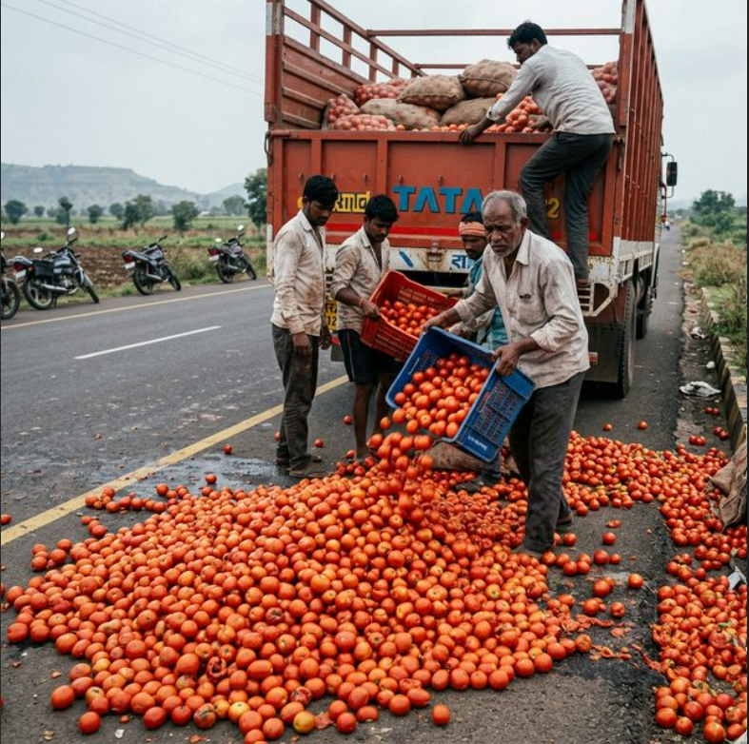

Fig 2.1: Farmers dumping excess tomatoes on the roadside due to oversupply and lack of market demand.

MOTIVATION

Despite its importance, farmers continue to face numerous challenges, including unpredictable climatic conditions, lack of access to real-time information, and poor decision-making support systems. One of the most critical issues observed in rural agricultural practices is the tendency of farmers within a specific geographical region, such as a taluk, to cultivate the same crop based on traditional knowledge or peer influence. While this approach may initially seem beneficial, it often leads to overproduction, market saturation, and a subsequent decline in crop prices, resulting in reduced income and financial instability for farmers.
Existing agricultural support systems primarily focus on providing subsidies or general advisory services, but they often lack personalized, data-driven insights tailored to specific locations. Government initiatives like PM-KISAN provide financial assistance, yet they do not address the root problem of informed crop selection and market-oriented farming decisions. This gap highlights the need for a smarter, technology-driven solution that can empower farmers with actionable insights.
With the rapid advancement of technologies such as artificial intelligence, machine learning, and geospatial analytics, there is a significant opportunity to transform traditional farming practices into data-driven precision agriculture. By leveraging real-time data on soil conditions, weather patterns, and regional crop distribution, it is possible to guide farmers toward cultivating crops that are not only suitable for their land but also economically viable.
Furthermore, incorporating market price prediction into the decision-making process ensures that farmers are aware of future demand and price trends, enabling them to maximize profitability. This integrated approach not only reduces the risk of financial loss but also promotes sustainable agricultural practices by encouraging crop diversification.
The motivation behind this project is to bridge the gap between traditional farming and modern technological advancements by developing an intelligent platform that supports farmers in making informed, profitable, and sustainable agricultural decisions. Ultimately, the system aims to enhance farmer productivity, improve income stability, and contribute to the overall growth and resilience of the agricultural sector.

  - PROBLEM STATEMENTS
Farmers in many regions, particularly at the taluk level, tend to cultivate similar crops due to traditional practices, lack of awareness, and limited access to real-time agricultural insights. This leads to overproduction of certain crops, resulting in market saturation, price decline, and reduced profitability. Additionally, farmers often lack access to integrated information regarding soil health, climatic conditions, and future market trends, which are critical for making informed decisions.

Existing agricultural advisory systems primarily focus on environmental factors and fail to incorporate geographical crop distribution and economic forecasting. As a result, farmers are unable to optimize their crop choices based on both suitability and profitability. There is a need for a comprehensive, AI-driven system that utilizes geo-spatial data, machine learning, and market prediction techniques to provide personalized, location-specific crop recommendations. Such a system can help reduce economic losses, improve productivity, and support sustainable agricultural practices

  - Gap Identified
1.Limited focus on soil parameters
Most research considers only soil factors like pH, nitrogen, phosphorus, and potassium, ignoring climate, rainfall, and geographical influences.
2.Lack of multi-source data integration
Existing systems rely on a single or limited dataset instead of combining soil, weather, location, and seasonal data.
3.Inadequate AI-based crop health monitoring
Crop disease detection systems are often standalone and lack continuous monitoring and predictive capabilities.
4.Absence of real-time analysis
Many systems do not provide real-time or near real-time insights, reducing effectiveness in dynamic agricultural conditions.
5.Lack of region-specific recommendations
Models are generalized and fail to adapt to local climate, soil, and geographical variations.
6.Poor user accessibility and interface design
Complex systems with low usability make it difficult for farmers, especially in rural areas, to adopt them.
7.No integrated platform
Existing solutions treat crop recommendation and crop health monitoring separately instead of offering a unified system.

  - Objectives Of The Proposed Work
- To develop a web-based portal for farmers to register, log in, and manage their agricultural data efficiently.
- To analyze geographical crop distribution using GPS-based location data and identify crop saturation in specific regions.
- To design and implement a machine learning-based crop recommendation system using soil, climate, and environmental parameters.
- To integrate market price prediction using historical agricultural data to forecast future crop prices and profitability.
- To provide intelligent decision support by combining agronomic suitability and economic analysis for optimal crop selection.

2. LITERATURE SURVEY

The application of artificial intelligence and machine learning in agriculture has gained significant attention in recent years, particularly in the domain of crop recommendation and precision farming. Researchers have increasingly focused on data-driven approaches to enhance agricultural productivity and support informed decision-making. These systems typically analyze environmental, soil, and climatic parameters to recommend suitable crops for specific regions.

One of the notable studies, “Precision Agriculture: A Machine Learning Approach to Enhance Crop Selection,” proposed a system that utilizes essential parameters such as nitrogen, phosphorus, potassium, temperature, humidity, and rainfall for crop recommendation [2]. The study applied multiple machine learning algorithms, including Random Forest, Logistic Regression, and XGBoost, achieving an accuracy of approximately 96%. This highlights the effectiveness of ensemble learning methods in improving prediction accuracy. Similarly, the study “Machine Learning Based Crop Prediction and Recommendation System” emphasized the use of supervised learning techniques and identified Random Forest as a highly accurate model for crop classification tasks [4]. Further advancements in this field focus on integrating real-time environmental data to improve system performance. The research work “AI-Based Crop Recommendation System for Agriculture Using Machine Learning” demonstrates how dynamic data inputs, such as changing weather conditions, can significantly enhance prediction accuracy and agricultural efficiency [1].

These systems highlight the importance of adaptability in agricultural decision-support models.

Recent developments also include the use of deep learning techniques. For example, “AgroSense: Deep Learning-Based Crop Recommendation Using Soil Image Analysis” explores the application of neural networks to extract complex patterns from soil and environmental data, leading to improved recommendation accuracy [10]. Additionally, studies incorporating soil characteristics into machine learning models have shown that detailed soil information plays a crucial role in enhancing prediction reliability [11]. In addition to agronomic parameters, economic considerations have become an important aspect of modern crop recommendation systems. Recent research proposes hybrid approaches that combine machine learning techniques for crop suitability analysis with time-series models for market price prediction [5].

Moreover, several studies emphasize the importance of combining multiple datasets to improve model performance. Traditional models often face challenges such as overfitting and lack of adaptability to changing conditions. By incorporating time-series analysis, lag variables, and continuous data updates, these systems achieve better accuracy and robustness [6][9]. This highlights the need for comprehensive models that consider both spatial and temporal variations in agricultural data. In the context of modern agriculture, the integration of advanced technologies such as IoT, artificial intelligence, and cloud computing has significantly transformed farming practices. Research published in IEEE Spectrum discusses how AI-based agritech applications provide personalized recommendations to farmers, thereby improving productivity and decision-making efficiency [3]. These developments indicate a shift towards smart farming systems that rely on real-time data and intelligent analytics.

In regions like Bangalore and Karnataka, the adoption of precision agriculture technologies has shown promising results. The use of AI-based monitoring systems and modern tools has contributed to improved resource utilization and increased crop yield. However, most existing systems primarily focus on crop suitability or yield prediction and do not consider regional crop distribution or market dynamics.

Therefore, the proposed system aims to address these limitations by integrating geo-location-based crop analysis, machine learning-based recommendations, and market price prediction into a unified platform. By combining agronomic and economic factors, the system provides a comprehensive solution to enhance farmer productivity and profitability.

3. METHODOLOGY

The proposed AI-powered precision agriculture system is designed to recommend optimal crops based on geographical, environmental, and soil conditions to enhance farmer productivity. The methodology involves multiple stages including data collection, preprocessing, model development, and deployment.Diverse datasets are collected from reliable sources such as government agricultural portals, weather APIs, and soil databases. These datasets include parameters like soil type, pH level, temperature, rainfall, humidity, and geographical location (latitude and longitude). Historical crop yield data is also gathered to improve prediction accuracy.In the preprocessing stage, the collected data is cleaned and transformed to handle missing values, noise, and inconsistencies. Feature engineering techniques are applied to extract relevant attributes, such as seasonal patterns and soil fertility indices. The processed data is then normalized to ensure uniformity for model training.

Next, machine learning algorithms such as Decision Trees, Random Forest, or Gradient Boosting are employed to build the crop recommendation model. These models are trained using labeled datasets where inputs (environmental and soil factors) correspond to suitable crops. Model performance is evaluated using metrics like accuracy, precision, recall, and F1-score, and the best-performing model is selected. To enhance prediction reliability, real-time data integration is incorporated using APIs for weather forecasting and satellite-based inputs where available. This allows dynamic recommendations based on current environmental conditions. Additionally, Geographic Information System (GIS) techniques are used to map regional suitability and visualize crop recommendations spatially. The system is deployed as a user-friendly web or mobile application where farmers can input their location and soil details. The system processes this input through the trained model and provides crop recommendations along with expected yield insights and basic cultivation guidance.This methodology leverages artificial intelligence, real-time data, and geospatial analysis to provide accurate, location-specific crop recommendations, thereby improving decision-making and increasing agricultural productivity.

3.1 BLOCK DIAGRAM

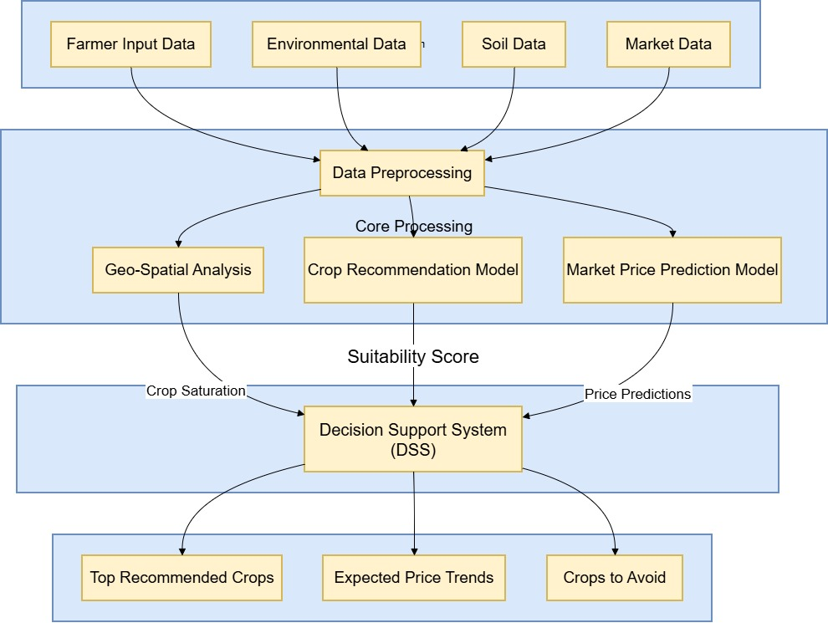
Fig.3.1. Farmer portal pipeline Block Diagram

The Block diagram of how the project model works is as shown below
Step 1: Multi-Source Data Ingestion
At this stage, the system acts as a central nervous system, aggregating diverse datasets necessary for calculating crop viability at an individual farm level.
- Farmer & Geographic Data: The exact Latitude and Longitude of the farm are captured. This is critical because soil composition and climate can drastically vary over just a few kilometers.
- Environmental Telemetry: Using REST APIs (like OpenWeather), the system executes continuous GET requests to fetch the current ambient Temperature (°C), Humidity (%), and Rainfall (mm). These act as the short-term biological triggers for crop growth.
- Soil Biometrics (NPK & pH): The core physical traits of the land are established. Nitrogen (N) drives leaf growth, Phosphorus (P) supports root/flower development, and Potassium (K) ensures overall plant health. The pH level dictates nutrient availability.
- Macro-Economic Data: Historical price arrays are pulled for multiple crops over the last 5–10 years to establish learning baselines for time-series models.
- Step 2: Data Preprocessing & Pipeline Architecture
Machine learning algorithms are essentially advanced math functions; they cannot natively understand text, nor can they handle missing numbers or massively different scales.
- Imputation: If a sensor fails or an AI times out, missing values (NaN) are synthetically replaced using mean substitution or K-Nearest Neighbors (KNN) imputation, ensuring the neural networks don't crash.
- Min-Max Normalization: Rainfall might be 1500 mm, while pH is 6.5. If fed directly into a model, the algorithm will mathematically assume rainfall is 200x more "important" than pH. Normalization mathematically forces every single variable into a [0.0 to 1.0] scale.
- Categorical Encoding: Text values (e.g., Soil Type = Alluvial) are converted into binary vectors using One-Hot Encoding so models can process them mathematically.
Step 2: The Dual Machine Learning Engine
This is the "Brain" of the platform, split into two separate predictive pathways: Biology and Economics.
Pathway A: Biological Suitability (Random Forest Classifier)
Instead of relying on a single decision tree, the Random Forest algorithm creates hundreds of independent decision trees.
The Process: The environmental vector V = [N, P, K, pH, Temp, Humidity, Rainfall] is passed into the forest. Each tree looks at different randomized subsets of the data and "votes" on whether a specific crop (e.g., Maize) will survive.
The Output: The system averages the votes across all trees to output a confidence percentage, which becomes the Suitability Score (e.g., 0.85 or 85% chance of survival).
Pathway B: Economic Forecasting (LSTM Networks)
Traditional algorithms fail to predict markets because prices have "memory" (last month's price heavily influences this month's).
The Process: Long Short-Term Memory (LSTM) is a highly advanced Recurrent Neural Network (RNN). It uses "Forget Gates" and "Input Gates" to decide which historical price trends are relevant seasonal events (like monsoon pricing) and which are just random market noise.
The Output: It outputs the predicted value of the crop in future months (when the crop is actually harvested), creating the normalized Price Prediction Score.
Step 3: Geo-Spatial Saturation & Game Theory
Even if a crop grows well and has a high predicted market price, it is extremely dangerous if every farmer in the county plants the identical crop. This causes local supply to exceed demand, crashing the wholesale price at the local Mandi (market).
1.Haversine Distance Mapping: The system calculates the curvature of the earth to draw a strict, accurate 10 km geo-fence around the user's farm based on their GPS coordinates.
2.Saturation Calculation: It checks the database for all active farms inside this radius and runs a frequency count. If 70% of local farms are planting Rice, the Saturation is exactly 0.70.
3.Algorithmic Penalty: The system calculates the Low Competition Score (1 - Saturation). For Rice, the score plummets to 0.30. This ensures the AI will actively route the farmer toward more unique, high-demand crops like Pulses or Maize to balance the local economy and protect profit margins.
Step 5: Decision Support System (DSS) Multi-Criteria Evaluation
The DSS is the final judge. It cannot just give the farmer the crop with the highest price, because it might physically die in the soil. It must balance Biology, Economics, and Market Saturation simultaneously.
The Multi-Criteria Synthesis Logic:
- 40% Weight to Biology (Suitability) - Because if the crop physically dies, the profit is absolutely zero.
- 30% Weight to High Price - To maximize farmer revenue.
- 30% Weight to Low Competition - To ensure the crop can actually be sold locally without price-crashing.
Final Score = (0.4 * Suitability) + (0.3 * Price) + (0.3 * Low Competition)
The system loops through all 22+ agricultural crops, calculates this exact equation for every single one, and dynamically renders the UI Dashboard. The top models are surfaced as "Highly Recommended", while any crop scoring dangerously low on biology or competition triggers a red "Do Not Grow" alert on the frontend.

3.2 FLOW CHART

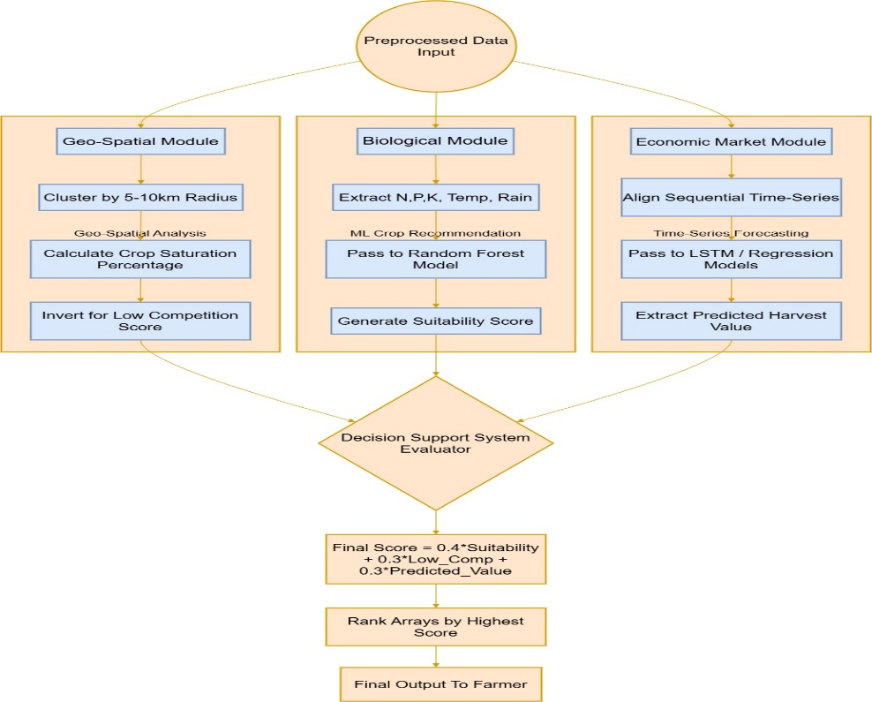

Fig 3.2: Flowchart of Algorithm flow of farmer porta
Phase 1: Rapid Development Using Large Language Models (LLMs)
The core of this project was built by leveraging LLMs as an intelligent development copilot to accelerate coding, design, and data processing.
Code Generation & UI/UX Design: LLMs were used to rapidly generate the frontend code (React, HTML/CSS) and build a premium, visually appealing user interface. The AI assisted in designing the "Farmer Registration Component," ensuring proper layout, responsive design, and integrating dynamic dropdowns for state, district, taluk, and hobli.
Data Processing & Structuring: LLMs were employed to analyze and clean the raw regional data (e.g., dakshina_kannada_crop_dataset.csv), identifying key features and transforming it into a structured format suitable for the portal's backend integration.
Database Architecture: AI assisted in writing the schema and logic for the local database (farmer_portal.db) to securely handle user registration and store sensitive farmer information like survey numbers and phone numbers.
Visual Enhancements: Generative AI tools were used to create custom, humanized agricultural background images and agricultural-themed icons to give the dashboard a polished, professional look.
Phase 2: Data Ingestion and Management
This phase outlines how real-world agricultural data is fed into the system to make it intelligent.
Static Dataset Integration: Regional agricultural data specifically the dakshina_kannada_crop_dataset.csv acts as the foundational knowledge base. This CSV is loaded into the system to provide historical context on what crops grow best in specific taluks/hoblis, expected yields, and local soil conditions.
Dynamic Database Storage: The system uses a relational database (farmer_portal.db) to store dynamic user inputs. When a farmer signs up, their profile data is written to this database, linking their specific farm (via survey number) to the broader agricultural database.
Data Mapping: The backend logic maps the farmer's registered location (District -> Taluk -> Hobli) directly to the patterns found in the CSV dataset, allowing the system to instantly filter and pull data relevant only to that specific farmer's land.
Phase 3: The Farmer's Journey
This phase describes exactly how a farmer interacts with the final product.
Step 1: Onboarding & Registration: The farmer arrives at the portal and is greeted by an easy-to-use, visually appealing registration form. They enter their Name, Phone Number, and select their exact location down to the Hobli and Survey Number using simple dropdown menus. Once they hit "Register," their profile is saved in the database.
Step 2: Accessing the Dashboard: Upon logging in, the farmer sees a personalized dashboard. Because the system knows their specific survey number and location, it automatically references the backend dataset (like the Dakshina Kannada dataset) to pull up local weather, soil conditions, and historical crop data specifically for their region.
Step 3: Receiving AI Insights: The farmer interacts with the interface to get advice. The portal uses the ingested data to show them:
Crop Recommendations: "Based on your land in this Taluk, groundnuts have the highest success rate."
Market Trends: Simple visual charts showing current or predicted prices for their specific crops.
Actionable Alerts: Timely advice on when to sow or harvest based on local conditions.

4. HARDWARE/SOFTWARE REQUIREMENTS
4.1 Software Components
The development of the proposed AI-powered precision agriculture system requires a combination of modern software technologies to ensure efficient data processing, scalability, and user accessibility. The software components are categorized into frontend, backend, database, machine learning tools, and supporting technologies.
Frontend Technologies
The user interface of the system is designed to be simple, responsive, and user-friendly so that farmers with minimal technical knowledge can easily interact with the platform. Technologies such as React are used for building dynamic web interfaces, while Flutter can be utilized for developing mobile applications. These frameworks enable real-time data visualization, interactive dashboards, and seamless navigation.
Backend Technologies
The backend is responsible for handling application logic, user authentication, and communication between the frontend and database. Frameworks like Node.js with Express or Django are used to develop RESTful APIs. These technologies ensure efficient handling of requests, secure data processing, and integration with machine learning models.
Database Management
A robust database system is essential for storing farmer details, crop data, geo-location information, and prediction results. PostgreSQL with PostGIS extension is preferred for handling geo-spatial queries, while MongoDB can be used for flexible data storage. The database ensures efficient retrieval and management of large-scale agricultural data.
Machine Learning Tools
The core intelligence of the system is powered by machine learning libraries such as Scikit-learn and TensorFlow. These tools are used to develop crop recommendation models and market price prediction systems. Additionally, Pandas and NumPy are used for data preprocessing and analysis.
APIs and External Services
The system integrates with external APIs to fetch real-time data. Weather data is obtained from Open Weather, while market price data is collected from government platforms such as Agmarknet. These integrations enhance the accuracy and reliability of predictions.
Deployment and Tools
For deployment, cloud platforms such as AWS and Vercel are used to ensure scalability and accessibility. Development tools like Visual Studio Code and Git are used for coding and version control.
4.2 Hardware Components Required
- Laptop/Desktop - Main development machine used to write code, run servers, and test the application
- Minimum 4 GB RAM - Required to run backend server, frontend server, and browser simultaneously
- Dual-core Processor -Handles multiple processes (Python backend + React frontend + browser)
- 10 GB Free Disk- Stores project files, datasets, database, and installed packages
- Internet Connection - Needed to fetch live weather data and market prices from external APIs
- Display Monitor -To view and interact with the application UI
- Keyboard and Mouse - For data entry and navigation
- Web Browser (Chrome) - To access and test the frontend application

4.3 Tools and Technologies Used with Standards
- Python 3.11 -Primary backend programming language used to write all server-side logic
- FastAPI - Modern Python web framework used to build the REST API endpoints
- Uvicorn - Lightweight ASGI server that runs the FastAPI application
- SQLite -Serverless database that stores farmer registration and login data
- Pydantic - Data validation library that checks incoming request data types and formats
- httpx -Python HTTP client used to call external APIs (weather, market prices)
- React 18 - JavaScript library used to build the interactive user interface
- TypeScript -Typed superset of JavaScript that adds type safety to frontend code
- Vite - Fast build tool and development server for the React frontend
- HTML -Markup language that defines the structure of web pages
- CSS - Stylesheet language used for visual design, animations, and responsive layout
- Node.js - JavaScript runtime that runs the frontend development tools
- npm - Package manager used to install frontend libraries and dependencies
- VS Code - Code editor used for writing, debugging, and managing the project
- Git - Version control system to track code changes
- pytest - Python testing framework used to run automated test cases
- FastAPI TestClient -Built-in tool that tests API endpoints without starting the server
- OpenWeatherMap API -External service providing real-time weather data (temperature, humidity, rainfall)
- data.gov.in API - Government API providing live APMC market commodity prices across Karnataka
- Weighted Distance Scoring Algorithm -Custom model that compares soil and weather conditions against crop data to recommend the best crops
- Windows 10/11 -Operating system used for development

4.4 Work Completed

1. Data Collection & Preparation

Collected crop data (pH, temperature, humidity, rainfall) for Dakshina Kannada 3001 rows

Collected 5-year market price history (2021–2025) for 7 crops 2941 rows

Generated 50 farmer profiles with yield, revenue, profit data across 5 years 250 rows

Created mock database for survey lookups and base market prices

2. Database Setup

Created SQLite database (farmer_portal.db) to store farmer registrations

Stores: name, phone, survey number, state, district, taluk, hobli, password, land area

3. Crop Recommendation Model

Built a weighted distance scoring algorithm

Compares user's soil pH, temperature, rainfall, humidity against dataset

Calculates similarity score for each crop

Returns top 5 best-matching crops sorted by score

4. Weather Integration

Connected OpenWeatherMap API for live weather data

Built fallback mock weather system if API key is missing

Feeds real-time temperature, humidity, rainfall into the recommendation model

5. Market Price Analysis

Connected data.gov.in API for live APMC market prices

Mapped all 31 Karnataka districts to their API names

Built taluk-wise price comparison from historical CSV data

Added trend analysis (up/down/stable) for each crop

6. Profit Estimation Model

Converts land area (acres + guntas) to total acres

Calculates average yield per acre from farmer dataset

Multiplies yield × current market price = estimated revenue

Subtracts 40% input cost = estimated profit

7. Backend API Development

Built 14 REST API endpoints using FastAPI

Endpoints: register, login, farmer-info, soil-data, survey lookup, weather, recommendations, market prices, market history, profit estimate, farmer lookup, district market prices

8. Frontend Development

Built React + TypeScript UI with Vite

Login/Register page with cascading dropdowns (State → District → Taluk → Hobli)

Dashboard with 3 tabs: Crop Recommendation, Market Rate Prediction, Farm Analysis

Glassmorphism design with animations

5. EXPECTED RESULT
The proposed AI-powered precision agriculture system is expected to provide a comprehensive and user-friendly platform that assists farmers in making informed decisions regarding crop selection and cultivation. Upon successful registration and login, farmers will be able to view a personalized dashboard displaying their farm details, nearby crop patterns, and real-time environmental conditions. The system will analyze geo-location data to identify the types of crops grown in surrounding areas and detect crop saturation levels within a defined radius. Based on soil parameters, climatic conditions, and regional crop distribution, the system will generate a list of recommended crops that are most suitable for cultivation. Additionally, the platform will display crops that should be avoided due to overproduction in the region. A key feature of the system is the integration of market price prediction, where farmers will be provided with insights into future price trends using historical data from sources such as Agmarknet.
This will enable farmers to choose crops that are not only suitable but also economically profitable. The system will also present visual representations such as charts and graphs to illustrate price trends and recommendations clearly. Overall, the expected output is a decision-support system that improves crop planning, reduces economic risk, and enhances productivity through data-driven insights.

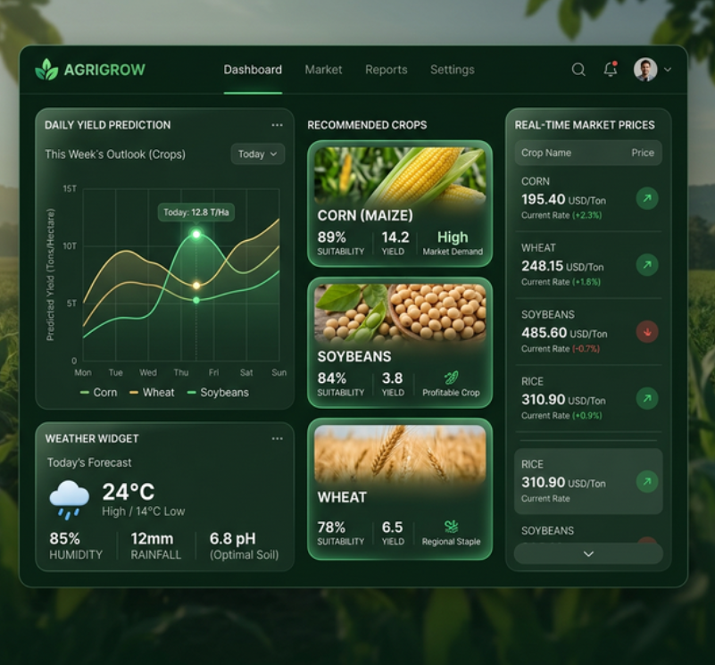
Fig 5.1: Expected output how the dashboard would look like.
6. APPLICATIONS AND CONTRIBUTION IN THR FIELD

The proposed AI-powered precision agriculture system has wide-ranging applications in modern farming, agribusiness, and government agricultural planning. It serves as a comprehensive decision-support tool that can significantly improve agricultural productivity and sustainability.
1. Smart Crop Selection for Farmers
The system helps farmers choose the most suitable crops based on soil health, weather conditions, and geographical location. By providing scientifically backed recommendations, it reduces dependency on traditional practices and improves yield quality and quantity.
2. Prevention of Crop Overproduction (Market Saturation Control)
By analyzing geo-spatial crop distribution, the system identifies which crops are already widely cultivated in a region. This helps farmers avoid growing the same crops, thereby preventing market saturation, stabilizing prices, and ensuring better profitability.
3. Agricultural Decision Support System (DSS)
The platform acts as an intelligent DSS by combining biological suitability, market price prediction, and competition analysis. Farmers receive data-driven insights that support better planning, sowing, and harvesting decisions.
4. Market Price Forecasting and Profit Optimization
Using historical market data and predictive models like LSTM, the system forecasts future crop prices. This enables farmers to select crops not only based on suitability but also on expected market demand and profitability.
5. Real-Time Farm Monitoring and Advisory
Integration with weather APIs allows real-time monitoring of environmental conditions such as rainfall, temperature, and humidity. Farmers can receive timely alerts and recommendations, improving crop management and reducing risks.
6. Precision Agriculture and Resource Optimization
The system promotes efficient use of resources such as water, fertilizers, and land. By recommending crops suitable for specific soil and climatic conditions, it minimizes wastage and supports sustainable farming practices.
7. Support for Government and Policy Makers
Government agencies can use the system to monitor regional crop patterns, predict production levels, and plan procurement strategies. It can also assist in policy-making for crop diversification and price stabilization.
8. Agricultural Extension Services
The platform can be used by agricultural officers and extension workers to provide personalized guidance to farmers. It bridges the gap between research institutions and rural farming communities.
9. Agribusiness and Supply Chain Optimization
Agricultural companies, traders, and supply chain managers can use the system to predict crop availability and plan logistics accordingly. This improves efficiency in storage, transportation, and distribution.
10. Climate-Smart Agriculture
By integrating climate data and predictive analytics, the system helps farmers adapt to changing environmental conditions. It supports climate-resilient farming practices and reduces the impact of unpredictable weather.
11. Digital Farming Platforms and Startups
The system can be extended into mobile applications or SaaS platforms for agritech startups. It provides a foundation for building scalable digital agriculture solutions.
12. Crop Health Monitoring Integration (Future Scope Application)
With the addition of AI-based image analysis, the system can be expanded to detect plant diseases and nutrient deficiencies, enabling early intervention and reducing crop losses.

7. CONCLUSION

The proposed system, “AI-Powered Precision Agriculture System for Geographical Crop Recommendation and Enhanced Farmer Productivity,” offers a comprehensive solution to some of the most pressing challenges faced by farmers today. By integrating geo-spatial analysis, machine learning techniques, and market price prediction, the system provides a holistic approach to agricultural decision-making. Unlike traditional methods that rely on experience and generalized advice, this platform delivers personalized recommendations based on real-time data and regional conditions.
The system not only helps in identifying suitable crops based on soil and climate factors but also addresses the critical issue of market saturation by analyzing nearby crop patterns. Furthermore, the inclusion of predictive analytics for market prices ensures that farmers can make economically viable decisions, thereby improving their income and reducing the risk of losses. In addition to enhancing productivity, the system promotes sustainable agricultural practices by encouraging crop diversification and efficient resource utilization. It also bridges the gap between modern technology and traditional farming, making advanced tools accessible to farmers through a simple digital interface.
In conclusion, the proposed solution has the potential to significantly improve the agricultural ecosystem by empowering farmers with intelligent insights, increasing profitability, and supporting long-term sustainability in the farming sector.

8. Bibliography

[1] Y. Akkem and S. K. Biswas, “Analysis of an intellectual mechanism of a novel crop recommendation system using improved heuristic algorithm-based attention and cascaded deep learning network,” 2025.
[2] S. Patel, A. Jasoliya, Y. Suthar, and S. Jani, “Machine Learning Algorithms for Crop Recommendation in Precision Agriculture,” Journal of Information Systems Engineering and Management, vol. 10, no. 3, 2025.
[3] E. Gent: “AI’s Green Thumb: Agritech Apps Providing Personalized Advice to Farmers,”
IEEE Spectrum, vol. 62, no. 2, pp. 32–39, 2025.
[4] D. Sharma, H. Raj, and C. H. N, “Machine Learning Based Crop Prediction and Recommendation System,” International Journal for Research in Applied Science & Engineering Technology, 2025.
[5] S. Banerjee et al :“Precision Agriculture Revolution: Integrating Digital Twins and Advanced Crop Recommendation,” IEEE-aligned research (Agriculture 4.0 systems), 2025.
[6] A. Badshah, B. Y. Alkazemi, F. Din, K. Z. Zamli, and M. Haris, “Crop Classification and Yield Prediction Using Robust Machine Learning Models for Agricultural Sustainability,” 2024.
[7] S. Kumar and M. Kumar, “Developing an XAI-based crop recommendation framework using soil nutrient profiles and historical crop yields,” 2025.
[8] J. Madhuri, B. R. Reddy, G. Kalnoor, M. Indiramma, and N. Nagarathna, “Optimizing crop recommendations with improved deep belief networks: A multimodal approach,” 2025.
[9] Saurabh Bhattacharya, Manju Pandey, “PCFRIMDS: Smart Next-Generation Approach for Precision Crop and Fertilizer Recommendations Using Integrated Multimodal Data Fusion for Sustainable Agriculture,” 2024
[10] V. Pandey, Ranjita Das, Debasmita Biswas, “AgroSence: An Integrated Deep Learning System for Crop Recommendation via Soil Image Analysis and Nutrient Profiling” , 2025
[11] H. Afzal et al: “Incorporating Soil Information with Machine Learning for Crop
Recommendation”, Scientific Reports (IEEE-level research impact), 2025

9. Mapping of Project Outcomes with Program Outcomes

Course Outcomes of the Project Student can be able  to | PO-1 | PO-2 | PO-3 | PO-4 | PO-5 | PO-6 | PO-7 | PO-8 | PO-9 | PO-10 | PO-11 | PO-12 | PSO1 | PSO2
Understand the key concepts of project management and project lifecycles. | 3 | 2 | 2 | 1 | 2 | 2 | 1 | 2 | 3 | 2 | 3 | 3 | 3 | 3
Investigate and manage a project using appropriate tools and  techniques. | 3 | 3 | 3 | 2 | 2 | 2 | 2 | 2 | 3 | 2 | 3 | 3 | 3 | 3
Develop and implement strategies for  executing the project effectively. | 3 | 3 | 3 | 3 | 2 | 2 | 2 | 2 | 3 | 3 | 3 | 2 | 3 | 2
Analyse and solve problems related to project  management. | 3 | 3 | 3 | 3 | 2 | 2 | 2 | 2 | 3 | 3 | 3 | 2 | 3 | 2
Work effectively in teams to deliver  the project successfully. | 3 | 3 | 3 | 3 | 3 | 3 | 2 | 2 | 3 | 3 | 3 | 2 | 3 | 2

